

**Reivers Service Desk Manual**

**Written by the staff of the service desk**

**Table of Contents**

**Mission Statement**

Our mission at the Reiver help desk is to deliver extensive support and to meet and exceed the expectations of our customers. The Reiver help desk prides itself on fulfilling the needs of others and delivering this service with a smile.

We will achieve this by:

* Laying out clearly defined expectations
* Offering extensive support at first contact
* Offering multiple points of contact
* Working to continually satisfy our customers

**Policy**

We have a clearly defined set of policies that our staff take pride in abiding by and fulfilling.

**Goals**

The goals of all our staff is to meet and exceed the expectations of our customers and to provide them with the services that they deserve.

**Purpose**

We are to be the single point of contact for all IT related incidents on campus.

**Procedures performed**

The following is some individual procedures performed by the service desk and detailed outlines on how they are done.

***Virus removal***

By far the most reported incident in the service desk is of a virus or some sort of malware on a client’s computer. The cause of a virus can vary, but asking the customer about his browsing habits can help in teaching them about prevention of future incidents. Remember that all data must be backed up before proceeding.

The standard procedure for virus removal goes as follows:

1. Download an antivirus executable onto a flash drive or other medium.



A popular antivirus tool that the help desk likes to use is MalwareBytes. Go to [www.malwarebytes.com](http://www.malwarebytes.com) and download the executable. Put the executable on a flash drive or other portable medium

1. Boot the problem computer into safe mode.

An easy method of going into safe mode is by running msconfig.exe and enabling safe mode on next boot followed by a restart into safe mode

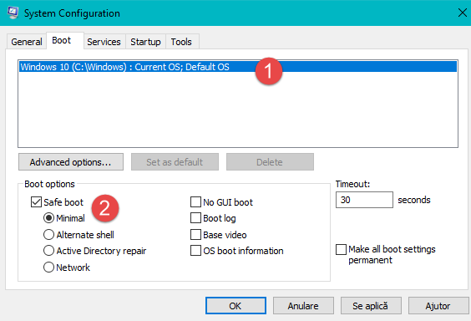

Another way of doing this is to hit restart while holding the shift key, which in turn will bring you to an option page.

When on the option page follow this combination of settings: Troubleshoot🡪Advanced Options🡪Startup settings. You can then select the safe mode option which will be represented by a number. This will bring up safe mode on the next boot.

1. Once in safe mode plug in your removable media and install the antivirus. Run the antivirus while in safe mode and try to remove the virus. Be sure to restart and verify that the virus has been removed.

Sometimes a virus cannot be removed this way. And requires more intrusive methods. One such method is to install an AV live medium to a flash drive and boot into it. A favorite of the help desk is the Kaspersky live antivirus medium

1. To find the ISO image and the installer go to <https://support.kaspersky.com/8092#block2> and follow the instructions to the links in the manual.

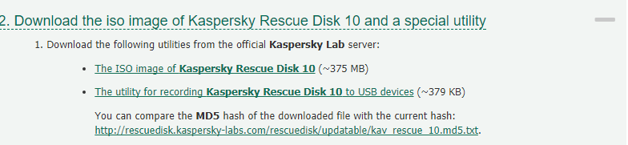

1. After downloading both utilities you need to install the utility for recording the Kaspersky Rescue Disk 10 OS. Install the utility and open it.
2. 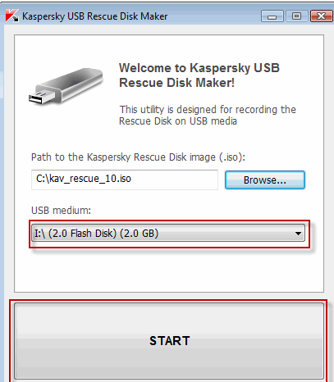

First you click browse, find your ISO file, select your USB medium, and allow it to image the disk.

1. You must then restart the machine and enable boot from removable disk from the BIO’s or UEFI. Be sure to have the flash drive plugged in before the computer POSTs.
2. 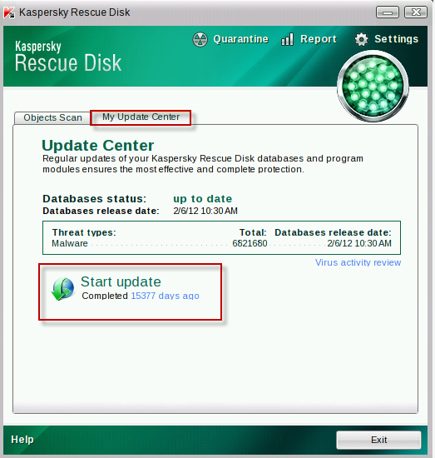You will boot into Kaspersky Rescue Disk 10, which navigating shouldn’t be too difficult if you are familiar with Linux. Enable the GUI interface and open the rescue disk program preinstalled to the OS.

It is extremely important that you update the databases before proceeding with the scan.

1. Finally click on objects scan, select your Windows Partition and scan it for Malware. Remove the viruses and attempt to boot back into windows.

***Screen Repair***

Laptop screen repair can cover a very broad spectrum because of the amounts of proprietary systems that exist with laptop manufacturers. This procedure will vary by the model of your laptop but this broad overview will give you a basic idea of what to do when going about it. Be sure to look up online guides when performing this procedure and back up all data before fumbling inside the laptop.

1. The first step in doing any work to an electrical device is to remove the power source. Unplug the battery and any power connectors and hold the power button to drain any excess electrical power. Be sure to discharge yourself of any static electricity before proceeding.

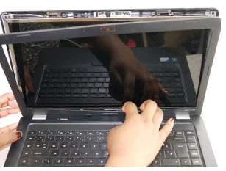

Usually laptops have removable bezels, and most HP and dell laptop bezels can pop right off to expose the screen. On some laptops you may be required to remove some screws or even take the bottom or the keyboard off but this is manufacturer dependent.

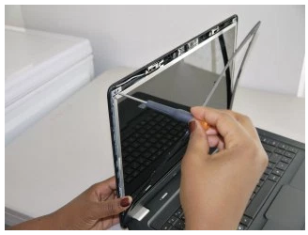

After the screen has been exposed you need to remove the screws holding the screen into place. The bezel may be still hanging or completely off the hinge but either way try not to damage it. Most screens have 4 screws with one in each corner of the screen.

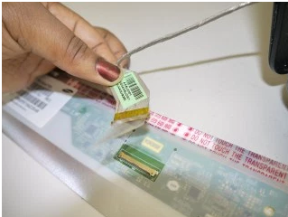

After removal of the screen you will notice that it’s attached by a small connector covered by a piece of tape. Remember that this is manufacturer specific but this is what you will see in most cases. Peel back the tape and firmly pull the connector straight out of its socket.

1. Now it’s time to replace the screen. Follow the steps in reverse and replace the broken screen. Don’t forget to firmly attach the connector to the new laptop and to reattach the tape that covers the connector.

***Installing an OS***

Many times when working in the service desk you may find yourself needing to fix a broken copy of windows or any other operating system. A good surefire way of fixing computers is to back up user data and reinstalling the OS. The following procedure is recommended for the service desk and covers a standard windows 10 installation

1. First you need to obtain an ISO and make it bootable. This can be done on a DVD, flash drive, or even a flash card. There are many ways to do this and that falls out of the scope of this procedure but there are many online guides outlining how to do this.
2. To boot from the medium you need to set your UEFI/BIO’s to boot from it. This can be done by pressing the manufacturer keystrokes and getting into your motherboard firmware settings. Usually this setting will be called boot priority. Set the priority and restart the machine with your medium plugged into the machine.
3. Boot into the OS, which could be a windows or Linux OS, depending on what you are installing. The standard service desk procedure outlines a standard Windows 10 installation.

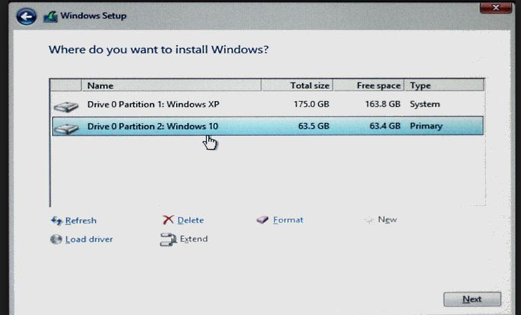

You will come to a page that looks like the following example. You will need to set up your partitions depending on how you want your computer set up. The example shows a dual boot configuration of 2 operating systems. If you are only installing 1 dedicated OS then use the entire allocated space for a partition.

1. You will then hit next and wait for the system to install itself. Be sure when the system restarts afterwards it boots off the hard drive and not the live medium. You must then set up user accounts, settings, and policies. Use default windows settings and install programs based on customers’ requests.

***General inquiry***

For general inquiries’ and requests you should follow this basic procedure. Inquiries can include installing software, updating programs, removing software, changing passwords, or training the customer. These requests are often quick and don’t usually require one to drop off their device for a later date.

1. Greet the customer with a standard professional greeting and ask them about their issue or request.
2. Have the customer fill out a ticket request while you create the ticket in the online ticket system.
3. Preform the specified task and inform the customer on any changes that you have made.
4. Ensure customer satisfaction. Make sure that all your changes are to the request of the customer and that his needs have been satisfied accordingly.

These general procedures may not outline all the procedures of the desk and you may be asked to fulfil a request outside the scope of this Manual. This can be considered normal and is up to the discretion of the person running the desk. You may receive requests outside the scope of the service desk and it is up to you to decide if you take these tickets or not.